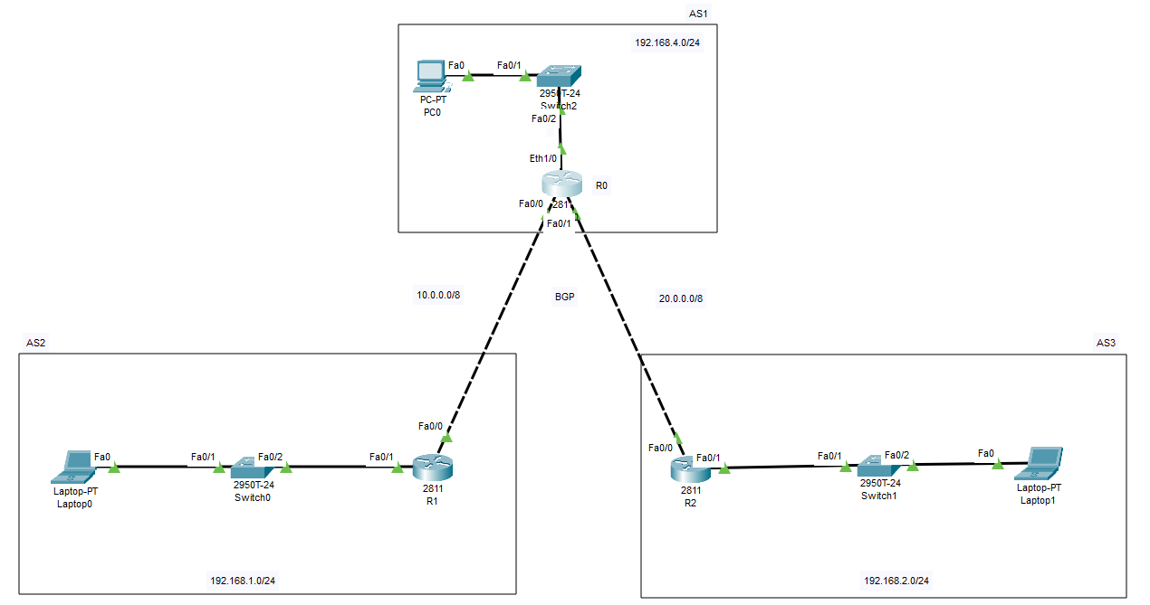

**Router R0**

|  |
| --- |
| Router>enable  Router#  Router#configure terminal  Enter configuration commands, one per line. End with CNTL/Z.  Router(config)#interface FastEthernet0/0  Router(config-if)#ip address 10.0.0.1 255.255.255.0  Router(config-if)#ip address 10.0.0.1 255.0.0.0  Router(config-if)#  Router(config-if)#exit  Router(config)#interface FastEthernet0/1  Router(config-if)#ip address 20.0.0.2 255.255.255.0  Router(config-if)#ip address 20.0.0.2 255.0.0.0  Router(config-if)#  Router(config-if)#exit  Router(config)#interface FastEthernet0/1  Router(config-if)#  Router(config-if)#exit  Router(config)#interface Ethernet1/0  Router(config-if)#  Router(config-if)#exit  Router(config)#interface FastEthernet0/0  Router(config-if)#  Router(config-if)#exit  Router(config)#interface Ethernet1/0  Router(config-if)#ip address 192.168.4.1 255.255.255.0  Router(config-if)#ip address 192.168.4.1 255.255.255.0  Router(config-if)#^Z  Router#  %SYS-5-CONFIG_I: Configured from console by console  Router#rou  Router#con  Router#conf t  Router#conf terminal  Enter configuration commands, one per line. End with CNTL/Z.  Router(config)#  Router(config)#rou  Router(config)#router bg  Router(config)#router bgp 1  Router(config-router)#net  Router(config-router)#network 192.168.4.0 mask 255.255.255.0  Router(config-router)#net 20.0.0.0 mask 255.0.0.0  Router(config-router)#net 10.0.0.0 mask 255.0.0.0  Router(config-router)#  Router(config-router)#neig  Router(config-router)#neighbor 10.0.0.2 ?  next-hop-self Disable the next hop calculation for this neighbor  remote-as Specify a BGP neighbor  Router(config-router)#neighbor 10.0.0.2 re  Router(config-router)#neighbor 10.0.0.2 remote-as 2  Router(config-router)#neig  Router(config-router)#neighbor 20.0.0.1 re  Router(config-router)#neighbor 20.0.0.1 remote-as 3  Router(config-router)#exit  Router(config)#  Router(config)#  Router(config)#interface FastEthernet0/0  Router(config-if)#ip address 10.0.0.1 255.0.0.0  Router(config-if)#%BGP-5-ADJCHANGE: neighbor 10.0.0.2 Up  Router(config-if)#exit  Router(config)#interface FastEthernet0/1  Router(config-if)#ip address 20.0.0.2 255.0.0.0  Router(config-if)#%BGP-5-ADJCHANGE: neighbor 20.0.0.1 Up  %BGP-3-NOTIFICATION: received from neighbor 10.0.0.2 4/0 (hold time expired) 0 bytes  %BGP-5-ADJCHANGE: neighbor 10.0.0.2 Up  Router(config-if)#^Z  Router#  %SYS-5-CONFIG_I: Configured from console by console  Router#wr  Building configuration...  [OK]  Router#sh  Router#show ip rou  Router#show ip route  Codes: L - local, C - connected, S - static, R - RIP, M - mobile, B - BGP  D - EIGRP, EX - EIGRP external, O - OSPF, IA - OSPF inter area  N1 - OSPF NSSA external type 1, N2 - OSPF NSSA external type 2  E1 - OSPF external type 1, E2 - OSPF external type 2, E - EGP  i - IS-IS, L1 - IS-IS level-1, L2 - IS-IS level-2, ia - IS-IS inter area  * - candidate default, U - per-user static route, o - ODR  P - periodic downloaded static route  Gateway of last resort is not set  10.0.0.0/8 is variably subnetted, 2 subnets, 2 masks  C 10.0.0.0/8 is directly connected, FastEthernet0/0  L 10.0.0.1/32 is directly connected, FastEthernet0/0  20.0.0.0/8 is variably subnetted, 2 subnets, 2 masks  C 20.0.0.0/8 is directly connected, FastEthernet0/1  L 20.0.0.2/32 is directly connected, FastEthernet0/1  B 192.168.1.0/24 [20/0] via 10.0.0.2, 00:00:00  B 192.168.2.0/24 [20/0] via 20.0.0.1, 00:00:00  192.168.4.0/24 is variably subnetted, 2 subnets, 2 masks  C 192.168.4.0/24 is directly connected, Ethernet1/0  L 192.168.4.1/32 is directly connected, Ethernet1/0 |

**Router R1**

|  |
| --- |
| Router>enable  Router#  Router#configure terminal  Enter configuration commands, one per line. End with CNTL/Z.  Router(config)#interface FastEthernet0/0  Router(config-if)#ip address 10.0.0.2 255.0.0.0  Router(config-if)#ip address 10.0.0.2 255.0.0.0  Router(config-if)#no shutdown  Router>enable  Router#  Router#configure terminal  Enter configuration commands, one per line. End with CNTL/Z.  Router(config)#interface FastEthernet0/0  Router(config-if)#  Router(config-if)#exit  Router(config)#  Router(config)#rou  Router(config)#router b  Router(config)#router bgp 2  Router(config-router)#net  Router(config-router)#network 192.168.1.0 mask 255.255.255.0  Router(config-router)#network 10.0.0.0 mask 255.0.0.0  Router(config-router)#  Router(config-router)#nei  Router(config-router)#neighbor 10.0.0.1 re  Router(config-router)#neighbor 10.0.0.1 remote-as 1  Router(config-router)#%BGP-5-ADJCHANGE: neighbor 10.0.0.1 Up  Router(config-router)#nei  Router(config-router)#exit  Router(config)#  Router(config)#  Router(config)#  Router(config)#interface FastEthernet0/0  Router(config-if)#ip address 10.0.0.2 255.0.0.0  Router(config-if)#  %BGP-3-NOTIFICATION: sent to neighbor 10.0.0.1 4/0 (hold time expired) 0 bytes  %BGP-5-ADJCHANGE: neighbor 10.0.0.1 Up  Router(config-if)#^Z  Router#  %SYS-5-CONFIG_I: Configured from console by console  Router#wr  Building configuration...  [OK] |

**Router R2**

|  |
| --- |
| Router>enable  Router#  Router#configure terminal  Enter configuration commands, one per line. End with CNTL/Z.  Router(config)#interface FastEthernet0/0  Router(config-if)#  Router(config-if)#  Router(config-if)#exit  Router(config)#interface FastEthernet0/0  Router(config-if)#  Router(config-if)#  Router(config-if)#exit  Router(config)#interface FastEthernet0/0  Router(config-if)#  Router(config-if)#exit  Router(config)#  Router(config)#rou  Router(config)#router b  Router(config)#router bgp 3  Router(config-router)#net  Router(config-router)#network 20.0.0.0 mask 255.0.0.0  Router(config-router)#netwo  Router(config-router)#network 192.168.2.0 mask 255.255.255.0  Router(config-router)#  Router(config-router)#nei  Router(config-router)#neighbor 20.0.0.2 re  Router(config-router)#neighbor 20.0.0.2 remote-as 1  Router(config-router)#%BGP-5-ADJCHANGE: neighbor 20.0.0.2 Up  Router(config-router)#nei  Router(config-router)#neighbor 10.0.0.2 re  Router(config-router)#neighbor 10.0.0.2 remote-as 2  Router(config-router)#ne  Router(config-router)#nei  Router(config-router)#exit  Router(config)#^Z  Router#  %SYS-5-CONFIG_I: Configured from console by console  Router#wr  Building configuration...  [OK] |